- Child Development 2 WEB & THEME Assignment-
Web designed used Bubbl.us web site – register for free access
Typed theme plan- created as Word Document.
- Cover Page – – title of theme, your name, assignment, and course, CD2
- Page 2- Create a web that will be shared with Child Development One. Brainstorm as many concepts and learning ideas you can about the theme you have chosen. 50 entries is a good start.
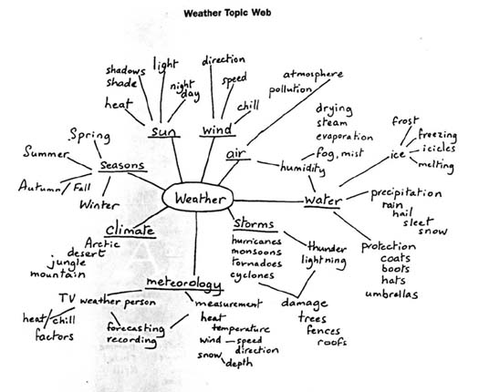
- Create a typed document with a title page, introductory paragraph of the theme, telling why you chose the theme and what instructional concepts you would like to teach the children.
- Page 3 -Math - Include 3 activities concepts: see your Child Development Binder for math ideas.
  - Addition – what can you add- number stories
  - Subtraction- what can you subtract – number stories
  - Patterns – what patterns can you make
  - Counting / One to One correspondence - what can you count.
  - Writing numbers
  - Graphing activities
    - Page 4 Vocabulary words – brainstorm 20-25 vocabulary words “nouns” that you could find a photo of for your Vocabulary book on topic their meaning for the theme. Think of science words like “condensation, evaporation, cocoon, rough, smooth” Not pants, snow, bird… Include the meaning of the word from a dictionary reference. Is there more than one meaning or a homonyms (flour and flower)
    - Page 4 continued - Locate four “4” picture books from our library – List the title and author 4 books from Amazon and their price, that you feel are related to our theme.
4 NON- Fiction –“real” factual books that teach about your theme from Amazon and their price
    - Page 5- Pre-Reading Skills- Include 3 activities concepts:
  - Learning Letters
  - A “Letters in your Name” activity
  - Initial sounds of vocabulary words
  - Rhyme nonsense and real words
  - Counts syllabus
  - Environmental print of theme if applicable
  - Retell story / finger play with paper puppets or puppets
  - Sequence events- making recipe, retelling a story sequence events
      - Page 6- Science – Include three science related discovery ideas that relate to your theme.
      - Page 7- Art – Process/ Expressive Art – include three process art related activities.
      - Page 8 References – list the websites you used to complete your project (minimum 4)
Name __________________________________ Date ______________________________________ Block ___________
CD2- Observation Text Book - Chapter 11 -Emergent Writing & Reading Checklist - Grading Rubric
Assignment Specification | Grade rubric | Grade
1.Assignment handed in on time – with directions and rubric attached to back for grading purposes. | 5 -on time  3 -one day late  0 (–2) for days late
2. Cover Page – title of theme, your name, assignment, and course, CD2 / CD 3 | 5 –meets expectations  3 –lower than expectations  0- Directions not followed
Web – 25 point assignment graded separately but handed in together.  Center of web clearly found (identifiable), title and your name in center of web. (5 points)  At least eight 8 sub topics ( see directions handout)  At least 50 contributing ideas to the web. | Theme title & name – 5 point  Web content – 20 points  Graded separately  Total possible 25 points
2. Clearly identified :  Name  CD2/ CD3 Title Assignment  Theme Introduction paragraph | 5 –meets expectations  3 –lower than expectations  0- Directions not followed`
3. Format and Construction:  Typed and Stapled  Correct paragraph form when needed.  Spelling and grammar usage | 5 –meets expectations  3 –lower than expectations  0- Directions not followed
3. Math activities-  No less than three activities, could be more, related to the instructional concepts of math (see your handouts)  Complete explanation, in Seven (7) or more sentences explaining the materials, directions, lesson prep & construction, learning objectives for EACH activity. Proper English Written paragraph form.  REFERENCES- EACH activity needs to be referenced as to which site you got the idea from- if the idea is yours make sure it meets a preschool learning objective. | 5 –meets expectations  3 –lower than expectations  .0- Directions not followed  Act1 Ref 5 3 1  Act2 Ref 5 3 1  Act3 Ref 5 3 1
4. Vocabulary – Brainstorm a list of 12 or more vocabulary words that could be “taught” to the students to increase their vocabularies. Real words that could be taught to children have been selected and the definitions are stated. | One point for each word that can be taught to the children and the definition. example  Boots, snow = 0  Condensation = 1
5. Picture Books-  Title & Author capitalized!  4 picture books from our classroom library.  4 books from Amazon and their price that you feel are related to our theme.  4 NON- Fiction – real books that teach about your theme. | 16 points total  One for each book correctly documenting the text.
6. Pre-Reading activities-  No less than three activities, could be more, related to the instructional concepts of pre reading/writing (see your handouts) Complete explanation, in Seven (7) or more sentences explaining the materials, directions, lesson prep & construction, learning objectives for EACH activity. Proper English Written paragraph form.  REFERENCES- EACH activity needs to be referenced as to which site you got the idea from- if the idea is yours make sure it meets a preschool learning objective. | 5 –meets expectations  3 –lower than expectations  .0- Directions not followed  Act1 Ref 5 3 1  Act2 Ref 5 3 1  Act3 Ref 5 3 1
7. Science activities-  No less than three activities, could be more, related to the instructional concepts of science (see your handouts)  Complete explanation, in Seven (7) or more sentences explaining the materials, directions, lesson prep & construction, learning objectives for EACH activity. Proper English Written paragraph form.  REFERENCES- EACH activity needs to be referenced as to which site you got the idea from- if the idea is yours make sure it meets a preschool learning objective. | 5 –meets expectations  3 –lower than expectations  .0- Directions not followed  Act1 Ref 5 3 1  Act2 Ref 5 3 1  Act3 Ref 5 3 1
8. Process Art-  No less than three activities, could be more, related to the instructional concepts of Process/ exploration ART (see your handouts)Complete explanation, in Seven (7) or more sentences explaining the materials, directions, lesson prep & construction, learning objectives for EACH activity. Proper English Written paragraph form.  REFERENCES- EACH activity needs to be referenced as to which site you got the idea from- if the idea is yours make sure it meets a preschool learning objective. | 5 –meets expectations  3 –lower than expectations  .0- Directions not followed  Act1 Ref 5 3 1  Act2 Ref 5 3 1  Act3 Ref 5 3 1
References- four Preschool website reference must be listed and identified in your sentences. Google is NOT a reference site. | 5 –meets expectations  3 –lower than expectations  0- Directions not followed
Total

