Environmental Print Mini Poster – Portfolio Assignment
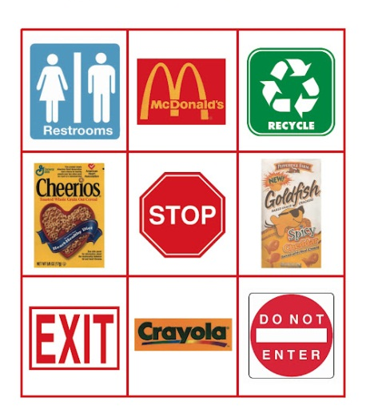
What is Environmental Print?
Reading print from the world around us is one of the beginning stages of literacy development. The letters, numbers, shapes, and colors found in logos for products and stores such as McDonald’s, Wal-Mart, Coke, and Campbell’s soup all provide opportunities for emerging readers to interact with print and the written word in their own environment. We see Environmental Print everywhere, we see logos and signs in our daily lives but as adults we don’t consider it real “reading”. However, Environmental Print is the first print a child learns to “read”.
Environmental Print Assignment
Use magazines, newspapers and advertisement to construct a collage of environmental print related to children. The Children should be able to easily identify the logos and marketing product by the package and logo.
Materials:
- Magazines, newspapers, advertisements
- Scissors
- Glue stick
- Piece of cardstock, Provided by Instructor
Grading-
- Cardstock material is used
- 20 to 30 logos are placed in mini poster
- Logos are attainted from newspaper, sale ads or magazines.
- Work is done neatly and is presentable,
- Glue in not seen, tape is not used.
- Fits in plastic protective sleeve.
- No adult images, products or logos are used or represented.
- Your name is displayed on the back of the mini poster

