Name ___________________________________ Date _______________ Block ___

ECD 108 Activities for School Age Children

**Game Demonstration and Presentation**

C:\Users\Kate\AppData\Local\Microsoft\Windows\Temporary Internet Files\Content.IE5\93GPX3KJ\MC900153900[1].wmf

**Directions**:

* Read and Review Chapter 10
* You will choose one of the indoor or outdoor game listed in the chapter.
* Teach the game to the Saturday teaching class.
* Demonstrate the game for children 5 to 12 years of age.
* You will implement the design of how this game could be used in your center.

Written Assignment:

* Your Name
* Game Name
* Idea ages of players
* Materials and supplies needed
* Rules
* How to implement the game in your center ( Bracket?)

**Fall / Spring Checker Challenge**

[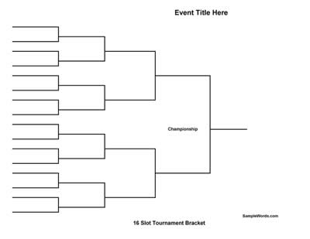](http://www.google.com/url?sa=i&rct=j&q=&esrc=s&frm=1&source=images&cd=&cad=rja&docid=5JOB_YtXzxggIM&tbnid=yU3mq7zYTdvf5M:&ved=0CAUQjRw&url=http://www.samplewords.com/cat/hobby-recreation-forms/tournament-brackets/&ei=Om5PUoamErbJ4APVg4HgBg&bvm=bv.53537100,d.dmg&psig=AFQjCNGiyYJweM_ZAz7UqPzJuP6ar1dLMw&ust=1381023647217472)